**10+1 Macam Query (Select, Where)**

1. SELECT * FROM `obat`

1. SELECT nama_obat, stok FROM `obat`;

1. SELECT * FROM `obat` WHERE stok = 30

1. SELECT * FROM `obat` WHERE stok > 30;

1. SELECT * FROM `obat` WHERE stok < 30;

1. SELECT * FROM `obat` WHERE stok >= 30;

1. SELECT * FROM `obat` WHERE stok <= 30;

1. SELECT * FROM `obat` WHERE stok <> 30;

1. SELECT * FROM `obat` WHERE stok BETWEEN 20 AND 40;

1. SELECT * FROM `detail_pembuat` WHERE domisili LIKE "b%";

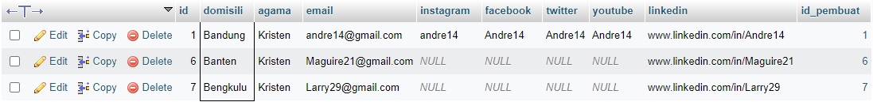

1. SELECT * FROM `detail_pembuat` WHERE domisili IN ("Bandung","Jakarta");

